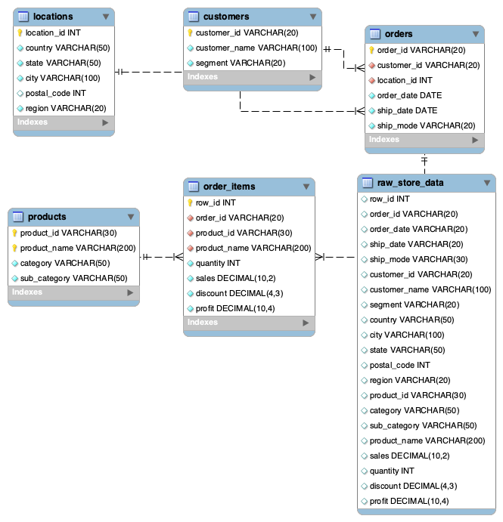

1. Visualization: Sales and profit analysis by product category
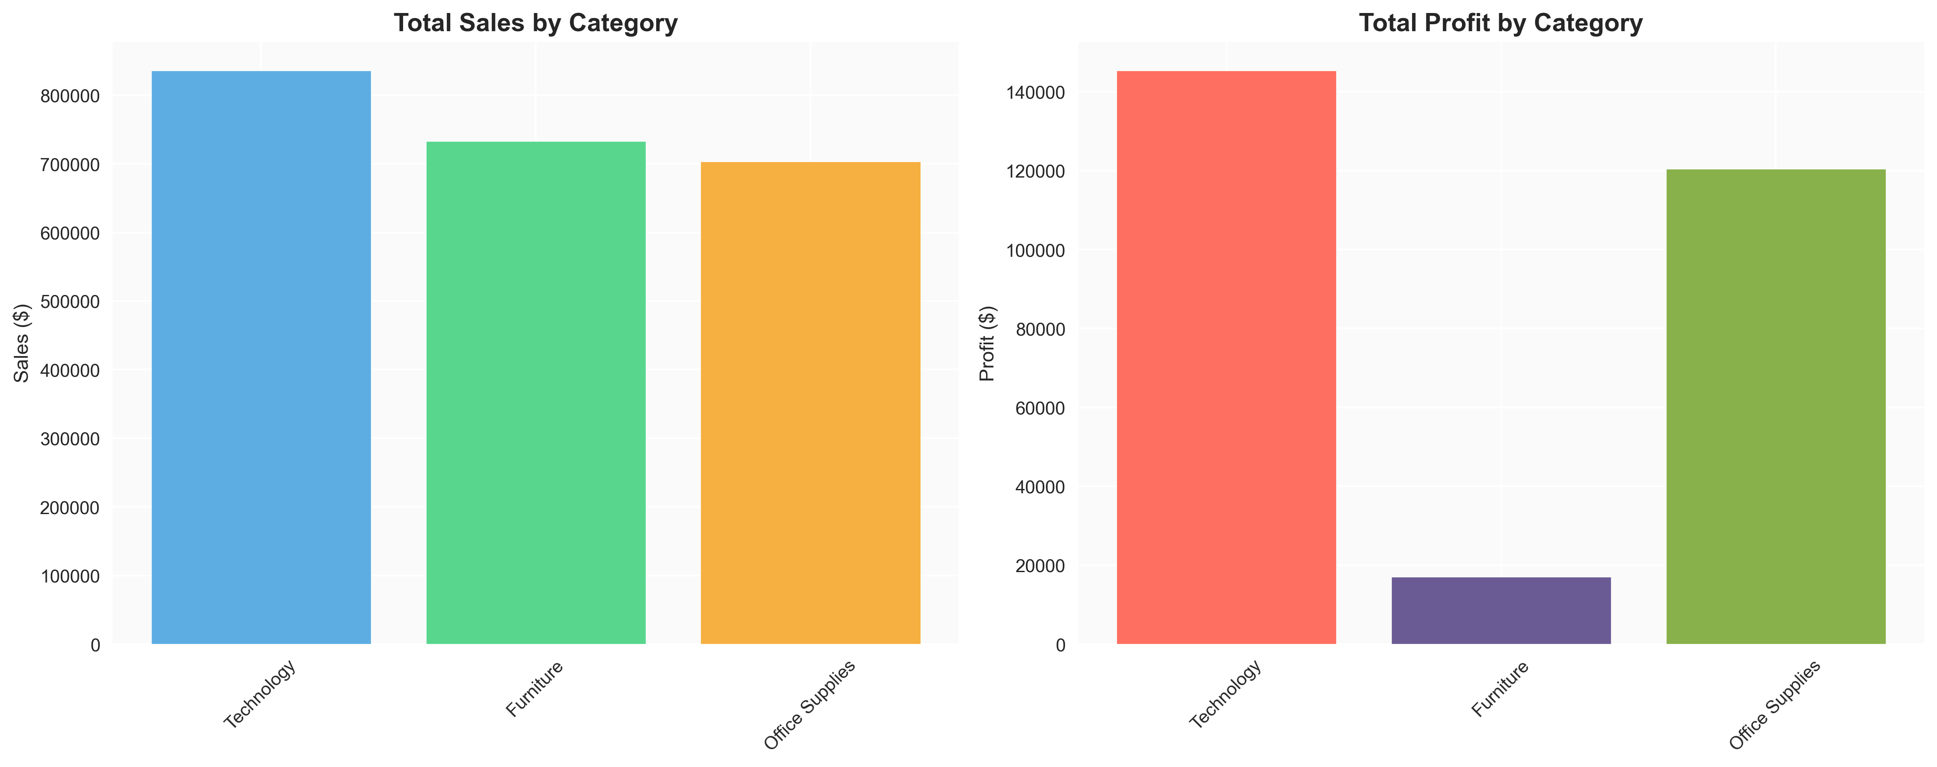
Why it's interesting/important:
- Technology dominance: Technology category leads with highest sales ($836K), demonstrating strong market demand for tech products
- Profit margin variations: While Technology has highest sales, it shows relatively lower profit margins compared to Office Supplies' more stable profitability
- Strategic insights: Helps optimize product portfolio by balancing high-volume and high-margin products
- Investment decisions: Provides data-driven guidance for inventory management and marketing budget allocation

2. Visualization: Regional sales distribution, profit comparison, Top 10 states by sales, and profit margin analysis
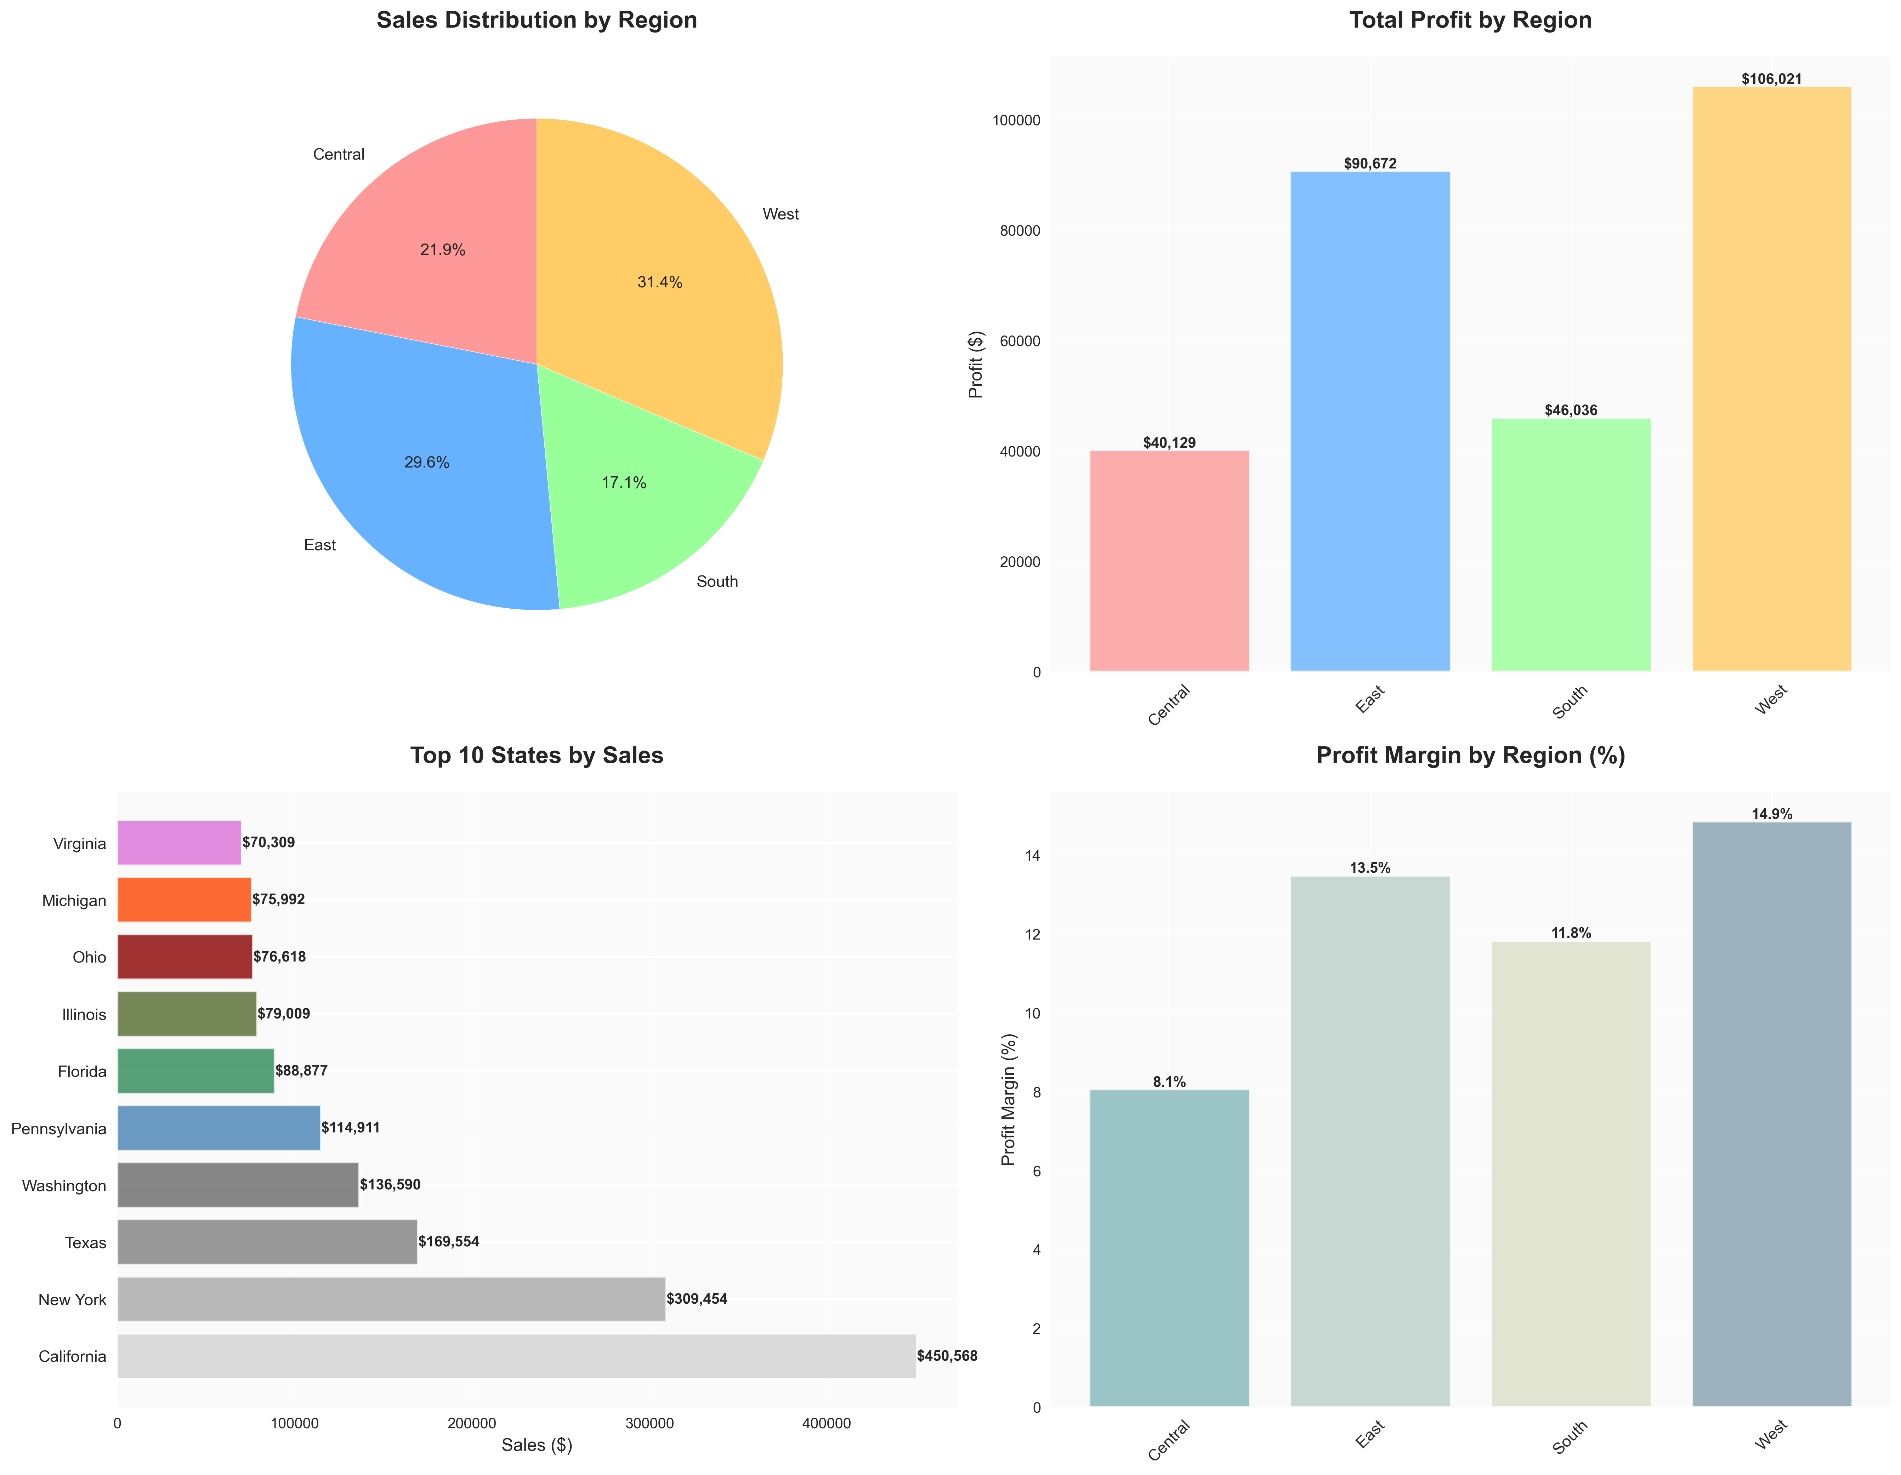
Why it's interesting/important:
- West region excellence: Accounts for 31.6% of total sales with 14.9% profit margin, representing our most valuable market
- Geographic opportunity identification: California, New York, and Texas lead in sales, highlighting potential in population-dense areas
- Operational efficiency insights: East and West regions show higher profit margins, possibly reflecting operational efficiency or pricing strategy differences
- Expansion strategy guidance: Provides clear direction for regional market investment and sales team allocation

3. Visualization: Customer segment distribution, sales contribution, average order value, and profit analysis
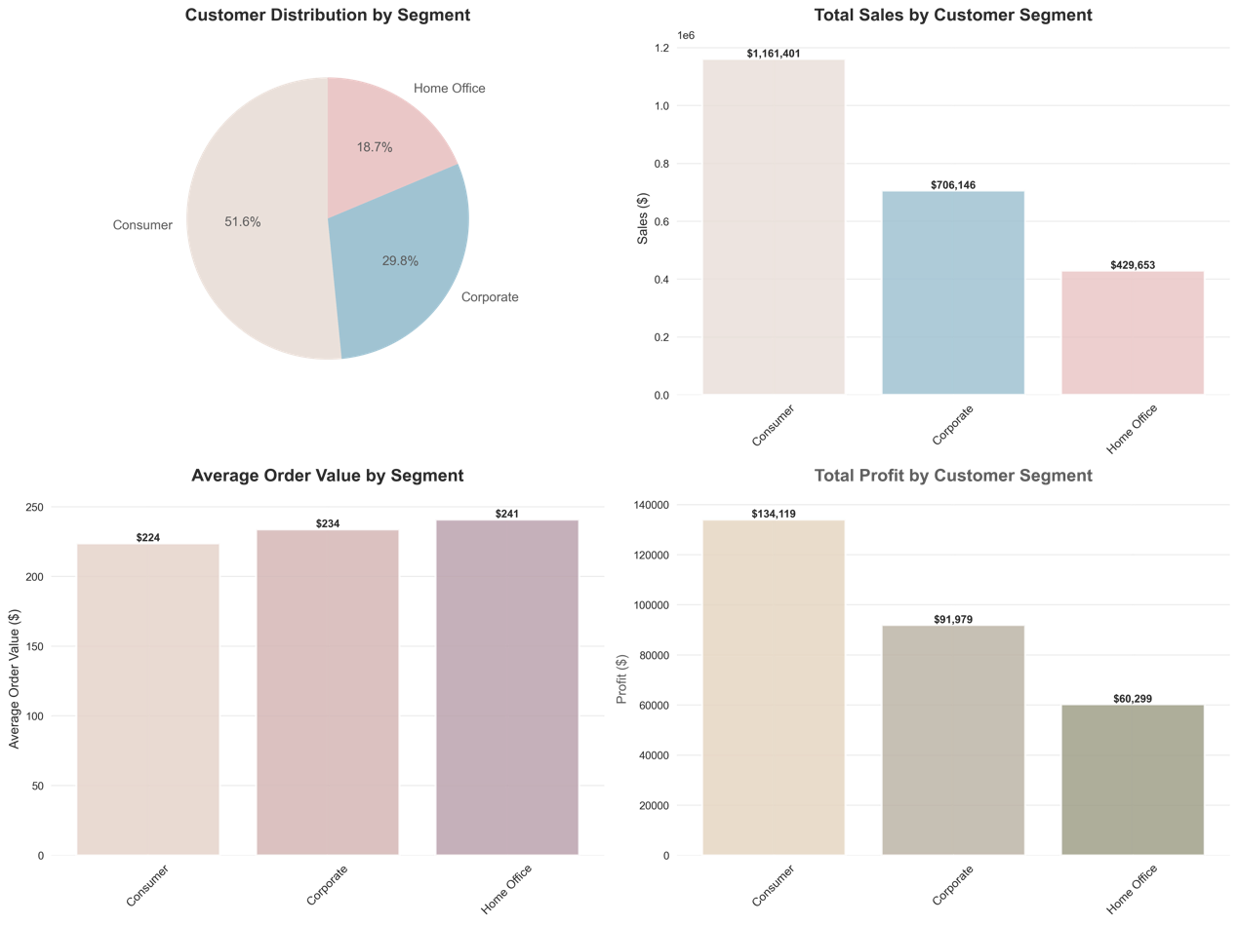
Why it's interesting/important:
- Consumer segment dominance: Represents 51.6% of customers while contributing highest sales ($1.16M), making them our core customer base
- Home Office high-value potential: Despite being smallest segment (18.7%), shows highest average order value ($241), indicating premium market opportunity
- Segmentation strategy value: Clear behavioral differences between segments require differentiated marketing approaches
- Customer lifetime value insights: Enables informed decisions on customer acquisition costs and retention strategies

4. Visualization: Monthly sales trends, profit trends, order count patterns, and sales-profit correlation analysis

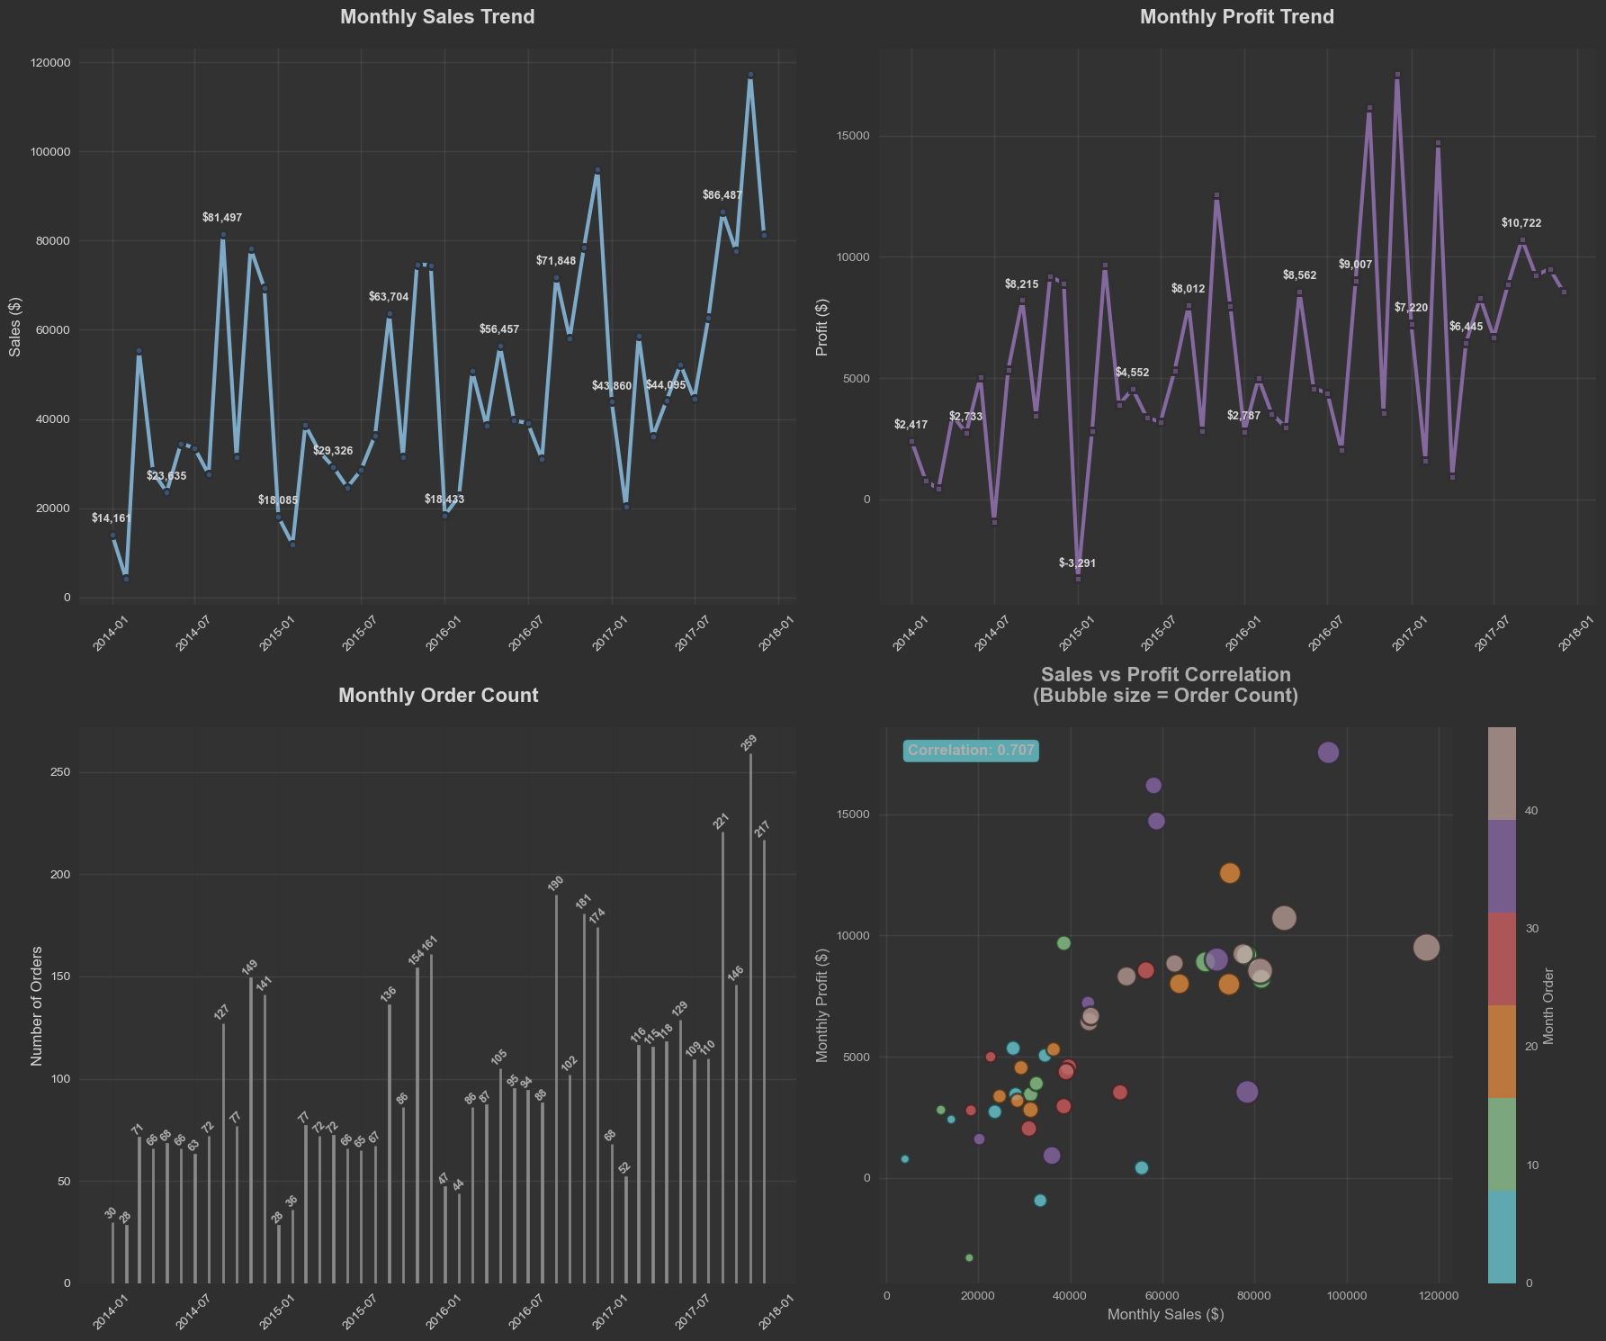

5. Visualization: Regional Segment Heatmap
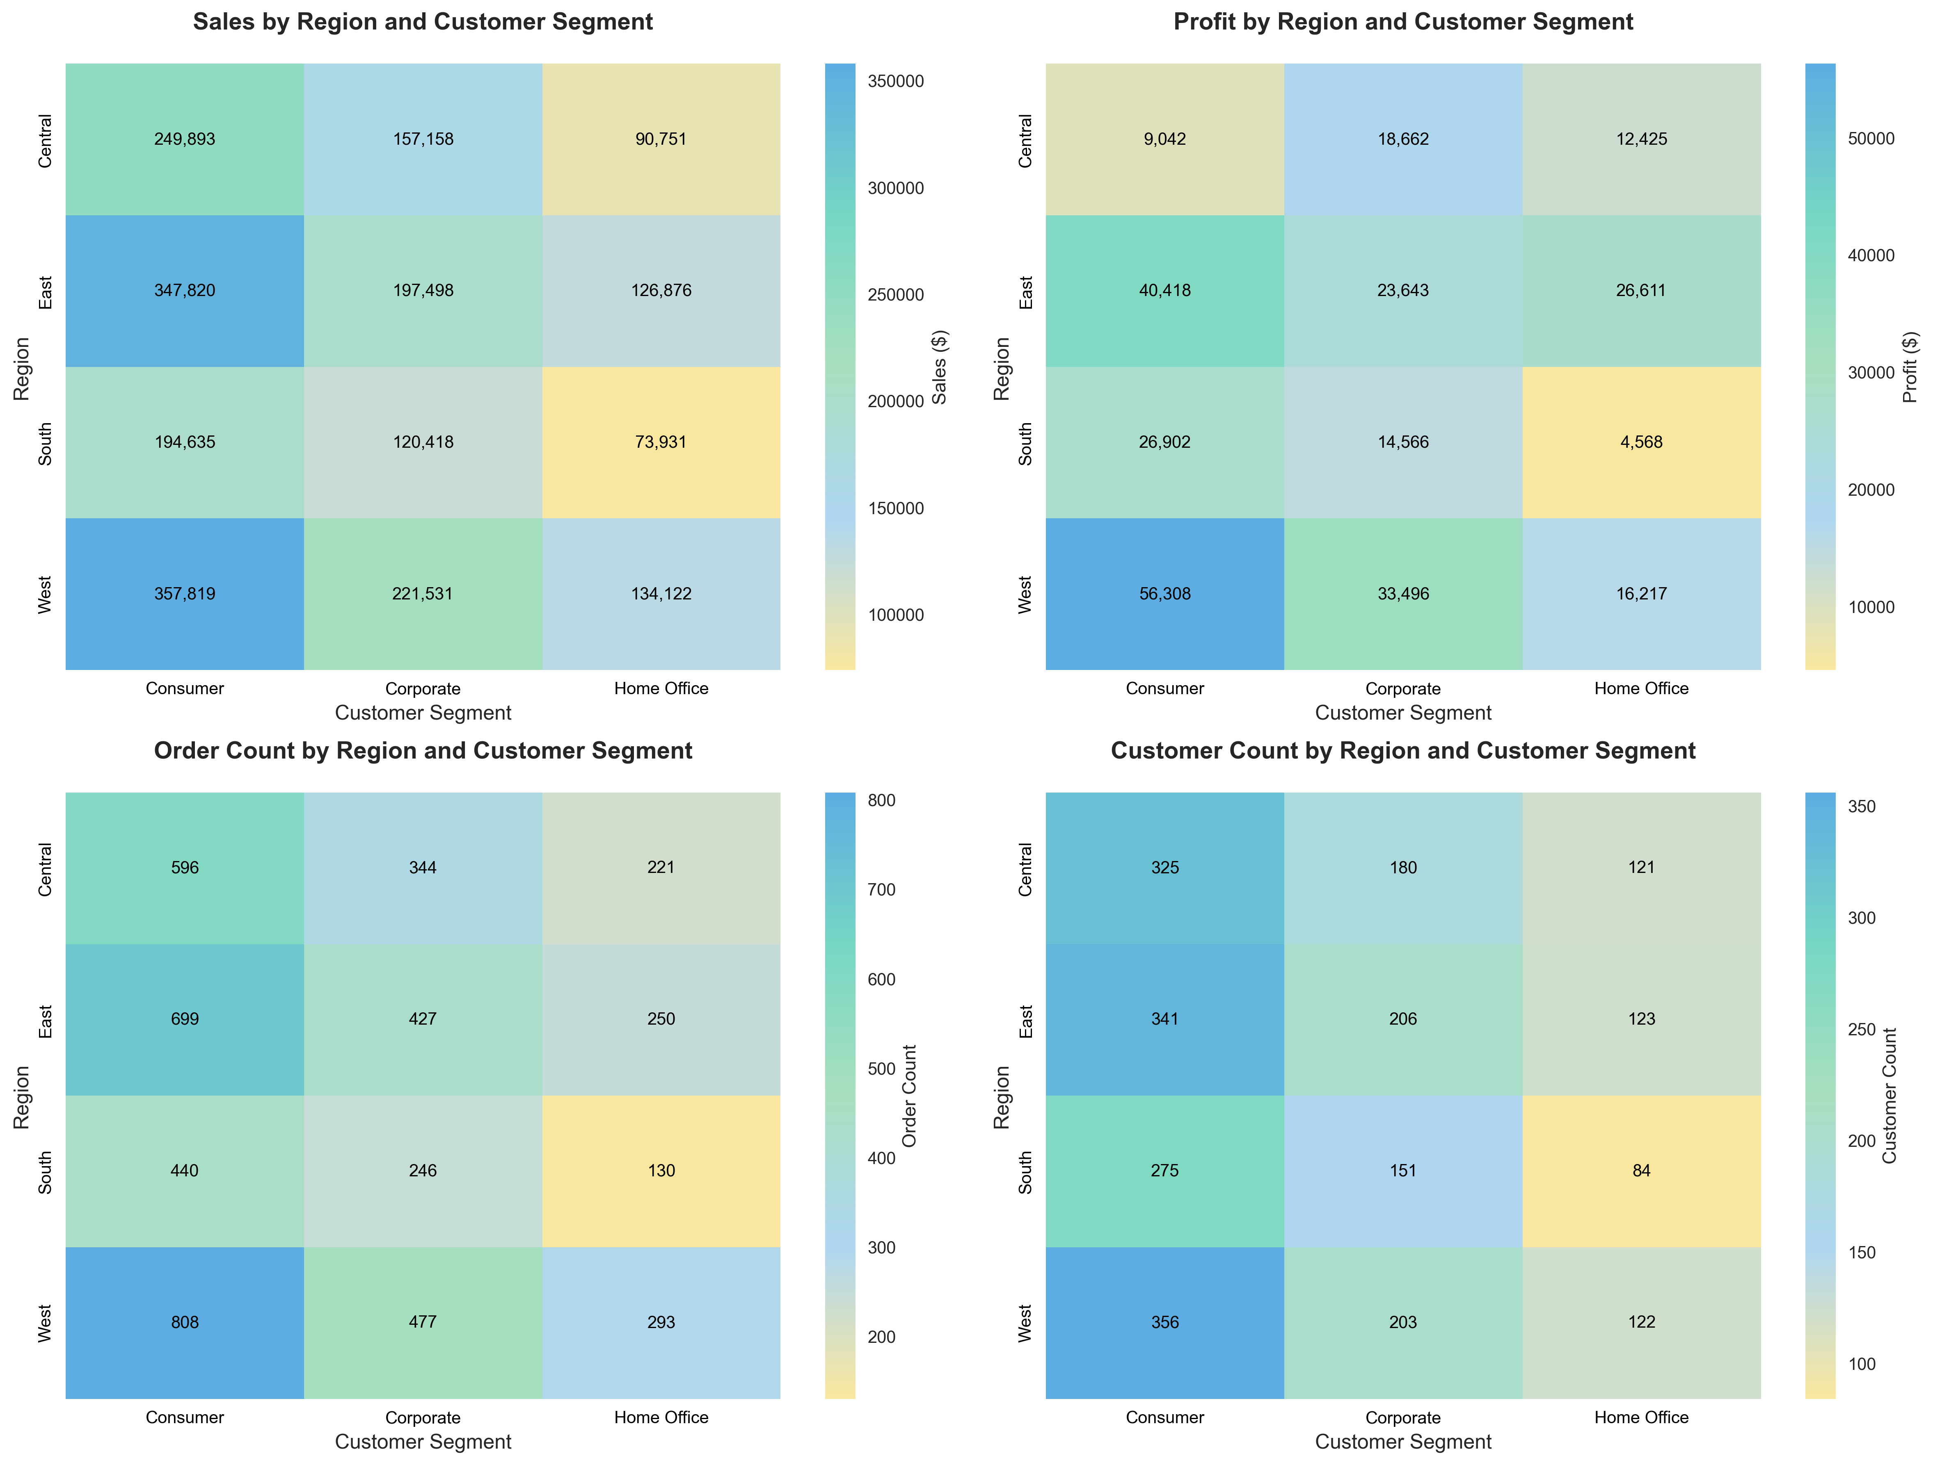

Why it's interesting/important:
- Seasonal patterns identified: Clear sales peaks at year-end, showing holiday and fiscal year-end impact on business
- Strong correlation confirmation: Sales-profit correlation of 0.716 indicates revenue growth aligns with profitability
- Growth trajectory validation: Significant growth in late 2017 reflects successful business expansion
- Forecasting value: Historical patterns provide foundation for future sales predictions and inventory planning
- Cash flow management: Helps predict revenue fluctuations for optimized financial planning

